

NEWSLETTER OF THE KENT PHILATELIC SOCIETY
P.O. Box 1156, Grand Rapids, Michigan 49501-1156
Louis Morel, President and Editor 269-420-3128
KentPhilatelicSociety.com
kps.stampclub@gmail.com

K.P.S. Philatelist
Volume 70- No. 8 August 2026

KPS Club News
Ron Rich has resigned his post as Club Secretary. We are in urgent need of a new Board member to fill his role.  Darrin Lettinga will continue managing the Club’s Facebook page until the end of this calendar year. The Club needs a member to succeed Darrin and oversee the Facebook page. The Club also needs a person to maintain its webpage.  The Club needs two members to form the Nominating Committee alongside two Board members. Its purpose is to seek members interested in serving on the Board in 2027.  As you can see, the Club is in great need of at least five members to step up and volunteer an hour or two per month. The oversight of the Facebook page and the Club’s webpage will come with training and full support. Contact Louis Morel for additional information. Will you answer the call?  We extend our gratitude to those volunteer members who helped prepare the third annual Summer Stamp Social. Fifty-seven people participated. Good conversations. Good food. Satisfying acquisitions. Lots of door prizes. We thank you for joining us. | Member Lee Oppenheimer attended AriPex 2026, the annual stamp show held in Mesa, Arizona in February. At last month’s meeting, Lee shared the conversation he had with the chairperson of the event. Thank you. Lee.  This month, Darrin Lettinga will offer a presentation titled “Collecting a Stamp Series or Making a Collection from One Stamp: The Small Format Definitives of Ghana”. It will start at 6:45.  The Kalamazoo Stamp Club is going to ChicagoPex in style. At the very least, they are going by bus. You can reserve a seat for the trip scheduled for Friday, November 20. The cost is $40 which is less than the cost of driving to the show in your own vehicle. Contact Paul Matyas by phone (269-365-8084) or by email (ltpali@aol.com) for more information or to reserve a seat.  Postal factoid: The USPS processed 131.8 billion pieces of mail in 2025. On average, this represents 10.8 billion pieces per month, 361.1 million per day, more than 15 million per hour, which is a whopping 4,180 each second. That’s down 1.4% compared to 2024!
The KPS Board will enhance our monthly auctions by holding a drawing for a FREE $10 certificate toward the winning purchases of one lucky member. You need to be present to participate in the drawing.

MONTHLY PROGRAM SCHEDULE
August 25, 2026: KPS CLUB MEETING  5:30 PM Board Meeting  6:00 PM Lot Viewing  6:45 PM Presentation and Floor Auction | September 22, 2026: KPS CLUB MEETING  5:30 PM Board Meeting  6:15 PM Lot Viewing  7:00 PM Dealer Auction: Chris Daly
The Kent Philatelic Society meets on the 4th Tuesday of the month at the Byron Center Baptist Church, 7343 Byron Center Ave SW, Byron Center.

Members are invited to share their philatelic experiences in this space. Perhaps you made a special acquisition, or thrive on an uncommon collecting topic, or saw a remarkable exhibit. Share it with your fellow collectors. Contact the Editor with your stories.
The Mahogany Tree
Saul Hudson, lead guitarist of Guns N’ Roses, best known as “Slash”, owns more than 230 guitars, including priceless vintage models. When he first tried a guitar made from “The Tree” the sound surpassed anything he’d heard before. David Knopfler, co-founder of the British rock band Dire Straits, owns one too. Andy McKee’s highly technical guitar performances have garnered tens of millions of views on YouTube. He owns a “Tree” guitar. Very few musicians own a guitar made from “The Tree”. The guitars range in price, but start around $30,000. What is “The Tree” that they are enamored with?

To answer this question, we must travel to Belize.
Hundreds of ruins and ceremonial centers show that for thousands of years Belize was populated by the Maya civilization that reached its peak known as the Classic Period between A.D. 250 and 900. At its height, the Maya of Belize and Central America formed one of the most densely populated and culturally dynamic societies in the world. Eventually, the civilization declined leaving behind large groups whose offspring still exist in Belize. From the mid-nineteenth century it was called British Honduras by the English invaders. In 1862, it became a colony, then a crown colony nine years later. In 1884, it got its own governor and became a separate colony. Belize gained its independence in 1981.

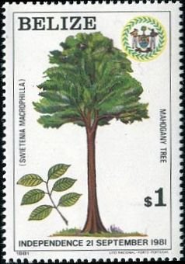
The British settlers who came to Belize in the early 18th century started importing African slaves to help cut logwood (used to produce dye) and later on, mahogany (shown at left, Belize, 1981, Scott 598). Mahogany had for centuries been the primary export. It was also a popular target of poachers and smugglers.

Mahogany was once so plentiful in Belize that the tree is featured on the nation’s flag, a flag that also portrays two shirtless loggers, each holding the tools of his trade. This is seen in the stamp nearby featuring King George VI and the aforementioned loggers (British Honduras, 1938, Scott 126). This emblem offers some idea of how important mahogany once was to the people of Belize, and also hints at how the tree came under threat. The great mahogany trees of Belize are severely depleted. And what about “The Tree”?


The tale is shrouded in some mystery. But we know it began in the Chiquibul jungle in 1965. Loggers found a majestic mahogany tree. It measured 12 feet at its base and was more than 100 feet tall. The rhythmic contortions of the bark were compelling. They suggested three-dimensional patterns beneath the surface. This was special timber, and almost certainly, quite valuable. Chain saws were scarce and useless as they got stuck in the hard core of the mahogany tree. They used handsaws and axes.

No one alive knows how long it took them to cut it down. What is known is that it didn’t go as planned. The tree fell in the wrong direction and crashed down a ravine. Two tractors could not extricate it.

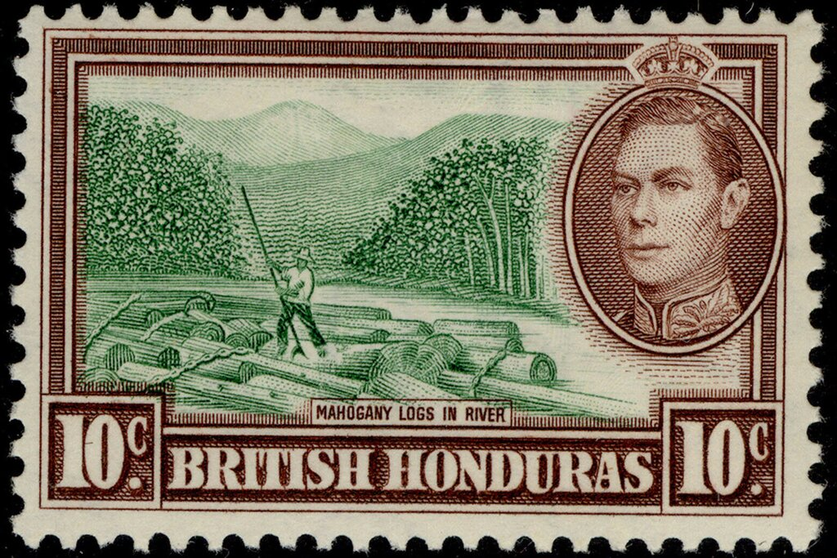
Several years later, an American importer of exotic woods, Robert Novak, heard of this tale. He traveled to Belize to see for himself. He eventually found the tree but could not figure out how to retrieve it. Novak was persistent if not obsessed. The tree was cut into quarters which were sliced into 15-foot-long logs that the loggers split lengthwise. They then used a tractor to drag the pieces one by one out of the ravine to the nearest road, and trucked them 120 miles or so to the Belize River, where they floated the final distance to an ancient steam-powered sawmill, the only mill in the region that could handle a tree of that size. The issue above (British Honduras, 1938, Scott 120) shows a logger directing mahogany logs in the current of a river.

Experts put the age of this tree at about 500 years. Having returned the lumber to the US, Novak sold much of the wood at ten times the price of oak.

Does “The Tree” have unique acoustical properties? Virtuoso musicians, “Slash”, David Knopfler, and Andy McKee think so. Are they being objective? A neuroscientist had six guitars built, varied only in the exotic woods used for the backs and side panels. The guitars were tested by 52 guitarists who sat in a dimly lit room wearing welder’s goggles. In many cases, the expert musicians could not even distinguish one guitar from the other.

Louis Morel

